TASK 20:

* Learning Azure AD
* Enable Azure AD Multi Factor Authentication setup.
* When you login to Azure portal it should authenticate using MFA.

**Learning:**

**Microsoft Azure Active Directory**, commonly known as Azure AD, is a system in Microsoft Azure that enables the identity management to configure accessibility of users and groups to services and resources.

Azure AD is intended for:

* IT Admins
* Developers
* Microsoft 365, Office 365**, or Dynamics CRM Online subscribers**

Another important use of Azure AD is that we can use to enable MFA(Multi-Factor Authentication Setup) per User so everytime a user login to Microsoft azure portal he/she will have to go through MFA setup to login to azure.

Steps to enable MFA for users in azure:

Step 1: Go to Azure Active Directory service by logging in inside Azure portal and then go to Users.

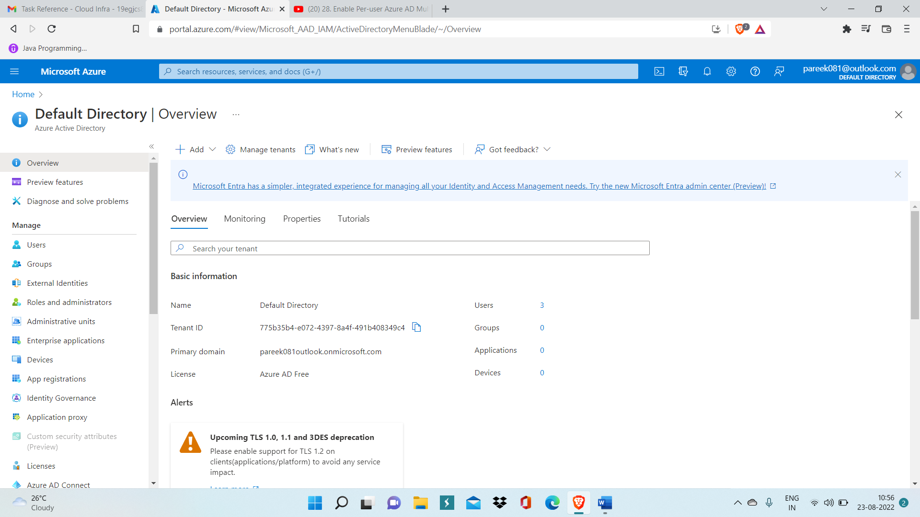

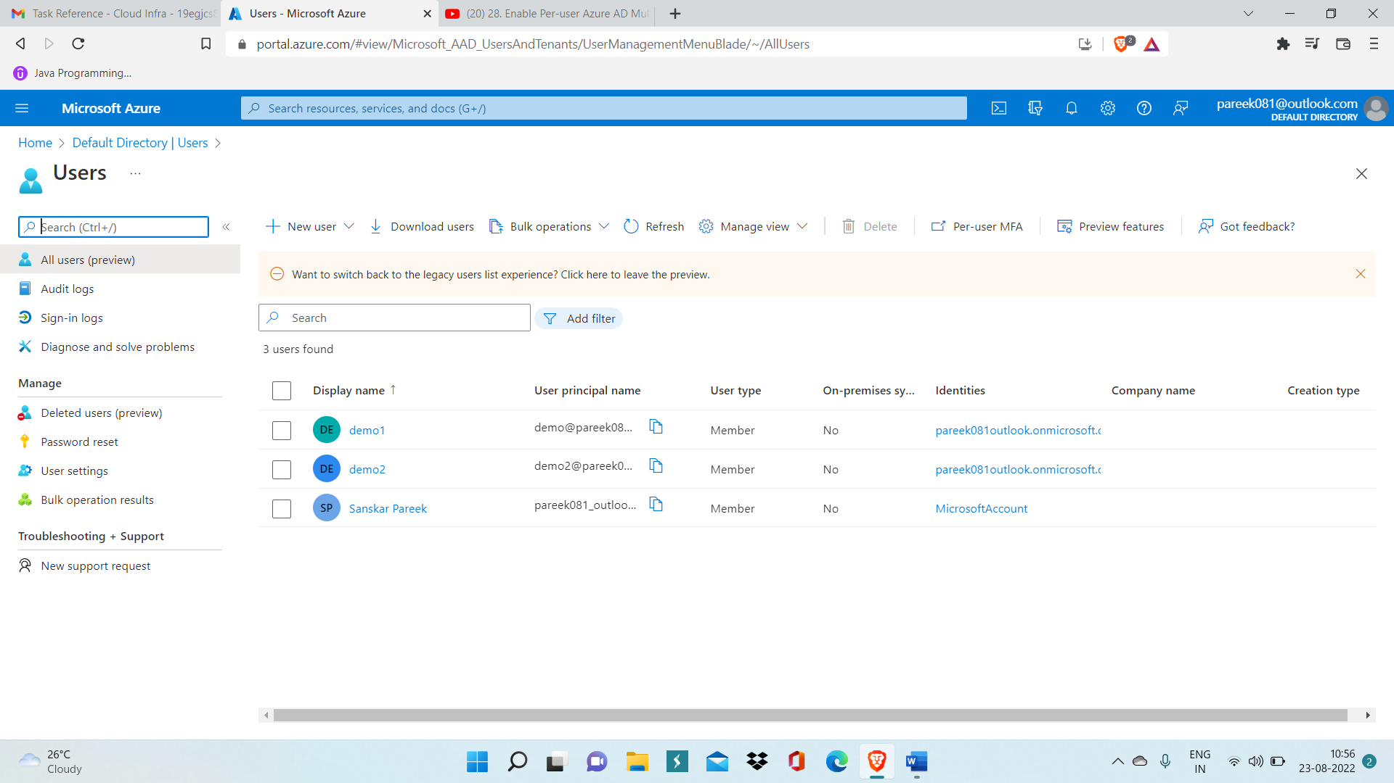

Step 3: Click on Per-user MFA and Multi-factor Authentication window will get opened in new tab.

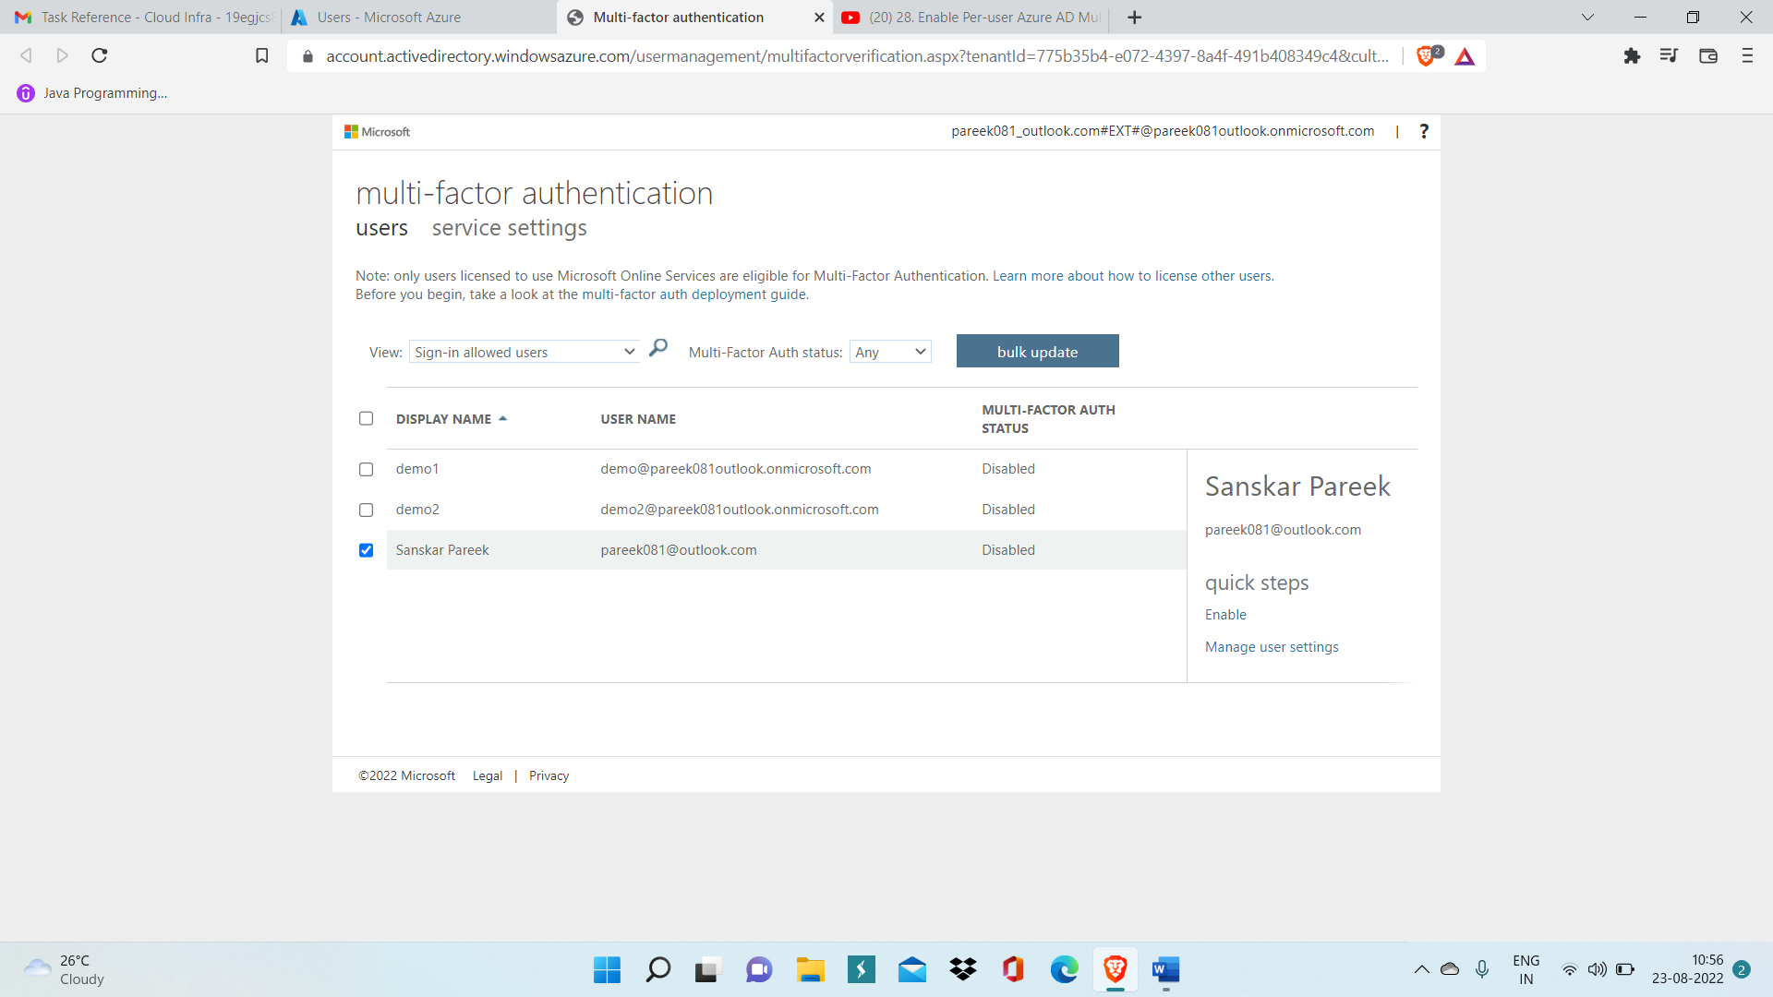

Step 4: Now select user with display name ‘Sanskar Pareek’ and click on enable inside quick steps.

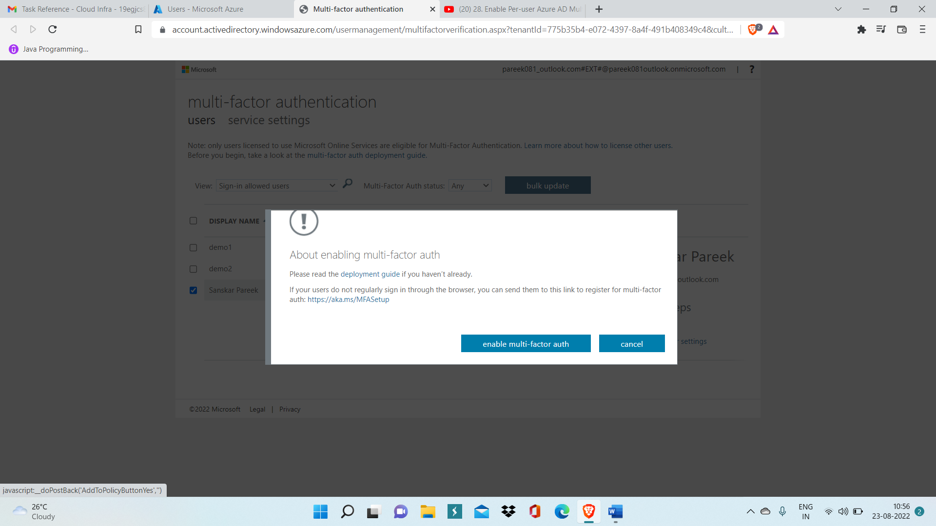

Step 5: Make sure you have Microsoft Authenticator app installed in phone of user who want to log in to azure.

Step 6: Open Private window and Open Azure Login Portal and enter email ID of user and then enter password.

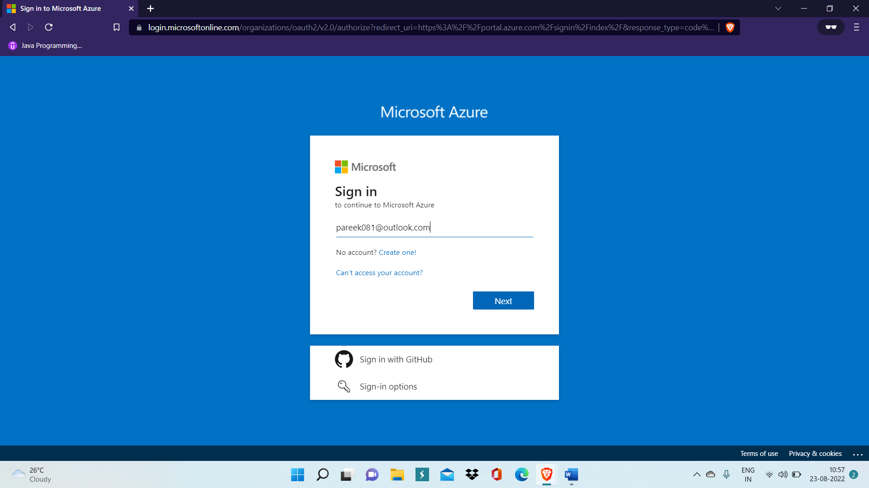

Step 7: Click on Use Microsoft Authenticator App, this will send an approve request to the verified user and wait for confirmation

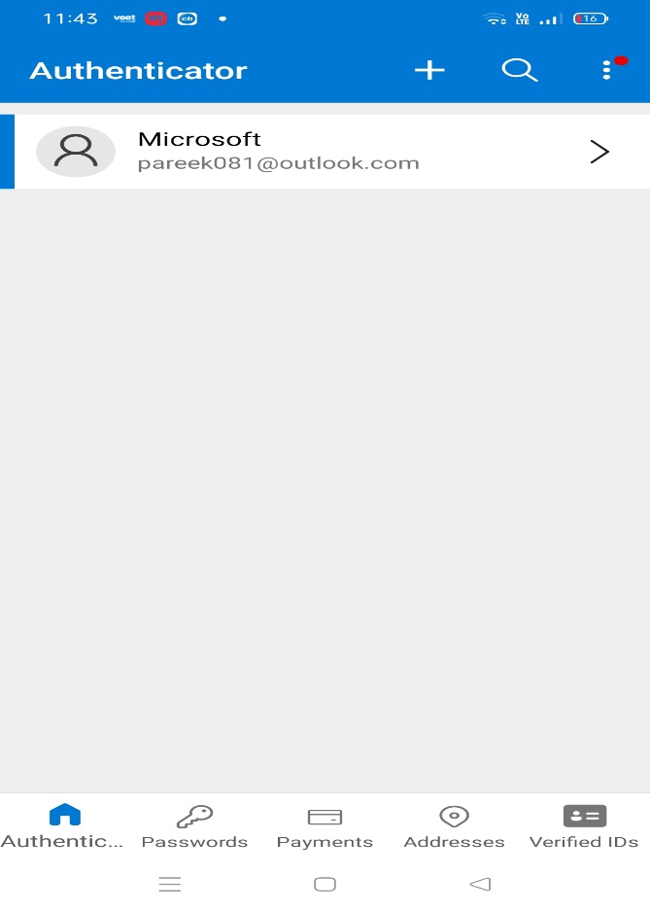

Above image shows the authenticator app in which we have already logged in with Microsoft account.

Step 8: Click on Approve and then you will be directly logged in to azure portal in your local computer through which MFA request has been sent.

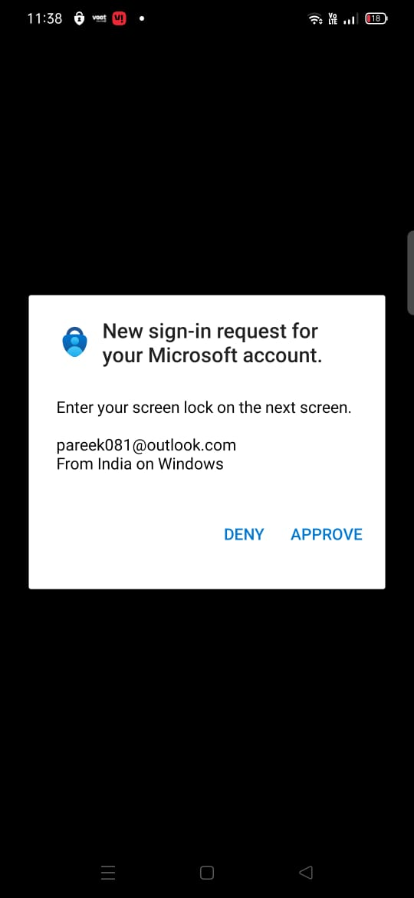

Now, you will be logged in to Azure portal.

